20261006
sftraining
Snowflake@2026!
AWS default Tokyo region VPC (Virtual Private Cloud)
Layers:
Cloud services layer: manages the infrastructure
Compute Resources: Virtual warehouse compute layer
Storage layer
Pricing: pay for what we use (credit based ig)

What is a session? A sql file is a session but what it is?
Is parquet file semistructured or unstructured?
Data Clustering:
Logical structure to physical structure.
As we insert the data gradually, snowflake creates micropartitions to store the data in a columnar fashion.
They are of size 50 to 500 mb (uncompressed data)
MPs have metadata for count & range (max, min) for numeric data and time stamp column.
Ex demonstrating speed of snowflake:
Select * from first_tbl;
No of rows scanned: 9, MP scanned: 3 (simultaneous scanning of MP)
Select * from first_tbl where id = 5;
Rows retrieved:1 , MP Scanned: 1
Sequential data
Ex2: not in sequence data
Select *
Where id = 5 (depends on data range okay)
Optimizable: there is a feature for clustering
MPs are immutable
Update first_tbl set name = ‘NameX’ where id = 5;
It goes to the micro-partition create an updated copy and marks the old for deletion.
Delete from first_tbl where id = 5;
Creates a new micro-partition and marks the older for deletion.
(time_travel option is available) it will be associated with a query id and timestamp.

Costing
Warehouse:Xsmall 1 credit / hour as long as session is active. We are being billed per second basis.
Loading records and time (1 billion records)
XS 12m 58 sec
S 6m 29 sec
M 3m 15 sec
Scaling up is done
Scaling out:
When multiple users are accessing a same dashboard at the same time
Mutli dimension warehouse
Steps:
Alter session set use_cached_result = false;

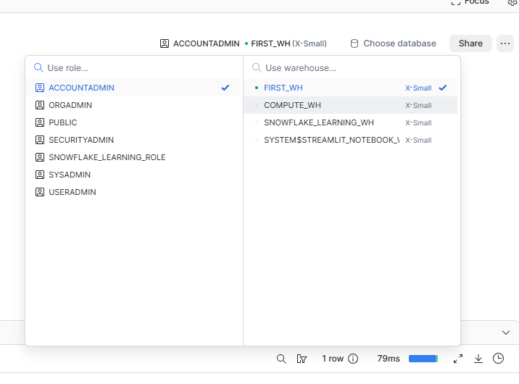
Accessing warehouse option

Show parameters for warehouse first_wh;
Clustering:
multi-cluster 2 cluster, 1 cluster 1 credit 2nd cluster 2 credit.

Day 2
Container hierarchy, tables, time travel, zero copy cloning, caching
Server:
Tables:
Permanent: all know what it is
Transient: same as permanent but less data protection (time travel upto 1 day, fail safe is N/A)
Temporary: exist within the session (time travel upto 1 day)
Purpose: improve performance of cte,
should have a grant to create table (it is an object)
Because of micropartitions the performance is high
Saving a bit on the compute cost within a session

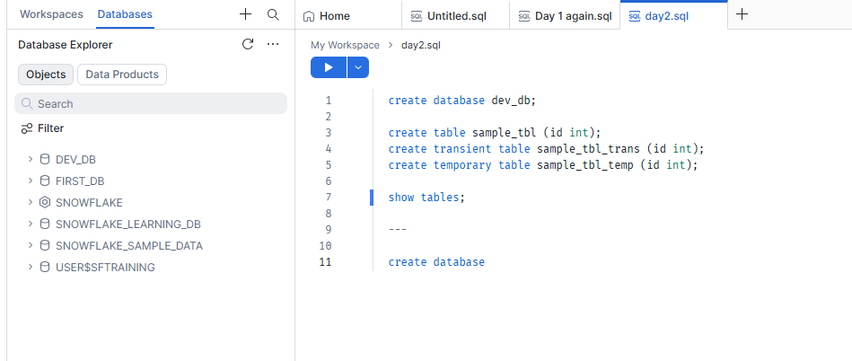
Databases icon cylindrical, what is the settings icon doing in database?
Situation 1: updated columns incorrectly
MP1, MP2: if you know the time stamp of MP2, use select * from table before the timestamp

Ex2: backup
create table backup_t1 as select * from supplier; -- it will consume storage
We can create it without storing, clone
Called zero copy cloning:

Ex3: Restoring data effectively using clone.
First determine the time travel
Statement id is one way to time travel
create a clone table
alter table supplier_clone swap with supplier;

Time travel:
A table is created, it will refer to original mps, when we update the table shows data of latest mp, but refers to all the mps. Thus, time travel is possible.
Drop stmt timetravel: use undrop;
Timestamp , offset, statement: assignment write what are these terms with example.

Fail safe period: once the time travel ends, reach out to snowflake support team and only they will be able to restore the data. But only for permanent tables.

We can change the retention at account level , also at table level
DATA_RETENTION_TIME_IN_DAYS = 6;
Cost in $ for this account:
Enterprise
Compute cost: 4… some dollar / hr
1TB: 25$ per month
Permanent table with default time travel as 1 day: we will be charged for 9 days even if the data is deleted after 1 day
Transient table with default time travel as 1 day, 2 days price will be charged
Higher the data protection higher the cost

Caching (Adaptive caching)
Metadata cache
Data cache
Query results cache

Virtual Warehouse cache: comes with a server capacity
Result cache: must be same query exact same not even additional or less filters.
Warehouse cache is active until session is active.
Prove it:

Topic changed to Information schema
Read only schema, information related to database and account.
You can go to usage and get the account details, table deleted.

Day 3
Loading data into snowflake and processing it (few excel files)
Catalog > Explorer > database , public, create stage file stage
Upload excel file
Load it into a table
Truncate vs delete use here: metadata associated with table
validation_mode = return_all_errors;

storage saving : stages
Day 4
OLTP and OLAP systems
Staging layer > Bronze > Gold > Silver
Logical Data model and physical data model (Idk)
Logical layer: silver, bronze, gold .. XD

